**Experiment No : 09**

**Title : Write a Python program to perform following operations on**

**Tuples:**

**a) Create**

**b) Access**

**c) Update**

**d) Delete**

**Problem statements:**

Create a tuple of 5 strings, and perform various operations.

**Theory :**

Tuple

Tuples are used to store multiple items in a single variable.Tuple is one of 4 built-in data types in Python used to store collections of data, the other 3 are [List](https://www.w3schools.com/python/python_lists.asp), [Set](https://www.w3schools.com/python/python_sets.asp), and [Dictionary](https://www.w3schools.com/python/python_dictionaries.asp), all with different qualities and usage.

A tuple is a collection which is ordered and unchangeable.

Tuples are written with round brackets.

Tuple Items

Tuple items are ordered, unchangeable, and allow duplicate values.

Tuple items are indexed, the first item has index [0], the second item has index [1] etc.

Ordered

When we say that tuples are ordered, it means that the items have a defined order, and that order will not change.

Unchangeable

Tuples are unchangeable, meaning that we cannot change, add or remove items after the tuple has been created.

Allow Duplicates

Since tuple are indexed, tuples can have items with the same value:

**Code :**

animals=()

#crete tuple

print('create tuple ')

n=5

for i in range(n):

    ele=input('enter element : ')

    x=*list*(animals)

    x.append(ele)

    animals=*tuple*(x)

#access tuple

print('\noriginal tuple ')

print(animals)

#update tuple

print('\nupdate tuple ')

n=*int*(input('enter position : '))

ele=input('enter element : ')

x=*list*(animals)

x[n]=ele

animals=*tuple*(x)

print('tuple after updation : ',animals)

print('\ndelete tuple ')

ele=input('enter element : ')

x=*list*(animals)

x.remove(ele)

animals=*tuple*(x)

print('tuple after deleting element : ',animals)

**Output:**

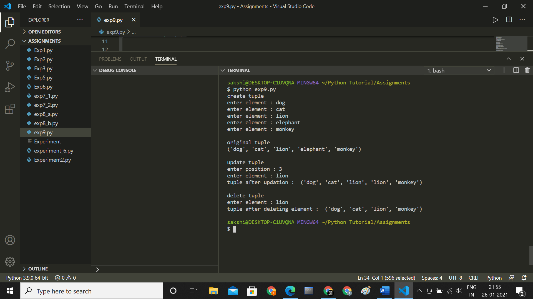

**Conclusion :**

**Thus we have understood how to write Python program to perform Create , Access, Update, Delete operations on Tuples.**